Overview
As a client, from MyAccount you can:
- nominate a representative to act on your behalf
- manage representatives online

Representative list screen.
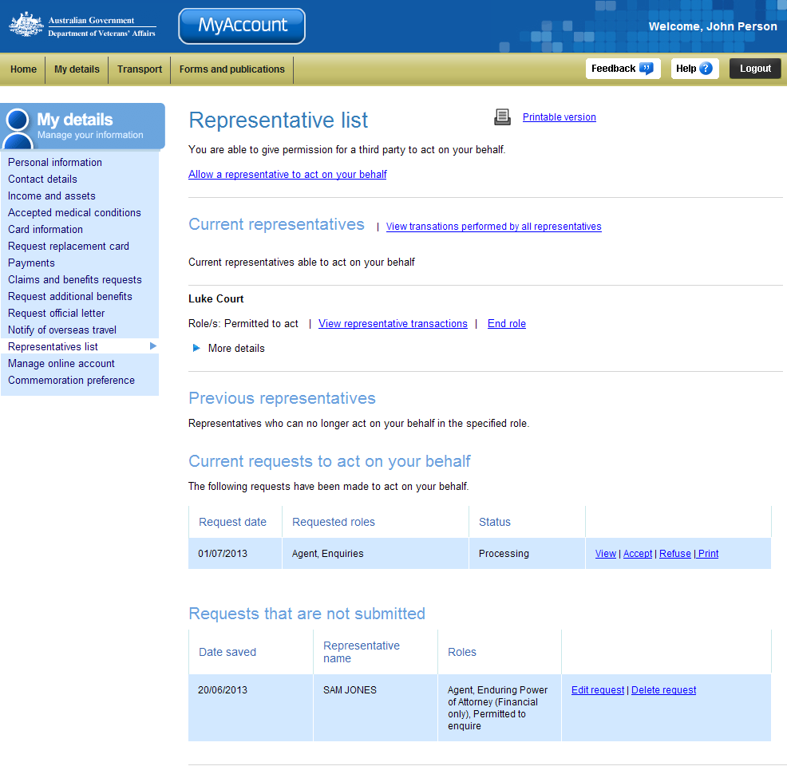
Nominate a representative
My details menu
View all transactions performed by representatives
Manage current representatives
Manage representative requests submitted
Previous representatives
Manage requests not submitted

Managing Representatives Online
From the Representative list screen you can manage your representatives online including:
- viewing transactions performed by representatives
- end a representatives role
- view previous representatives
- manage representative’s requests submitted and not submitted.

View transactions performed by all representatives
There are three ways you can view transactions performed on your behalf by representatives:
- by viewing all representatives
- by viewing a specific representative
- by viewing previous representatives.
To view transactions performed by all representatives:
- Select the View transactions performed by all representatives link.

The View representatives transactions screen displays.
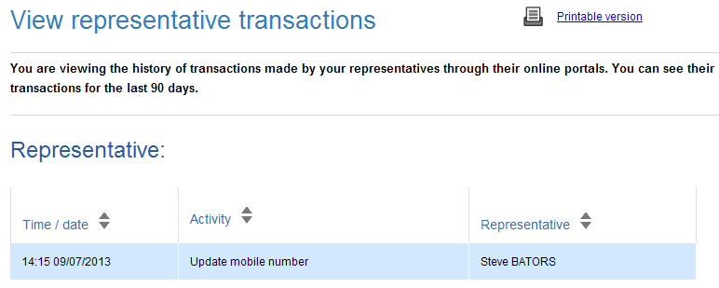
This screen displays the transactions performed in the last 90 days, what the transaction was and which representative performed it.
- Select the Printable version link to print the screen’s contents.

To view transactions performed by a specific representative:
- Select the View transactions performed link next to the specify representative.

The View representative transactions screen displays.
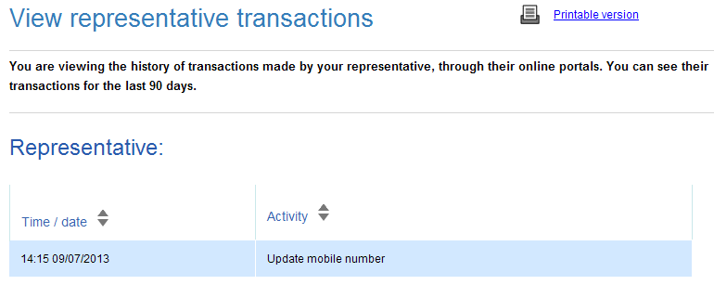
This screen displays only the transactions performed by the particular representative in the last 90 days and what the transaction was.
- Select the Printable version link to print the screen’s contents.

To view the transactions performed by previous representatives:
- In the Previous representatives section, select View representatives transactions against the specific representative.

The View representatives transactions screen displays.
This screen the transactions performed by the representative in the last 90 days and what the transaction was.
- Select the Printable version link to print the screen’s contents.

End role
When ending a representative’s role:
- if the representative holds multiple roles, you can end all roles or end a specific role
- If the representative only holds one role you will be ending their role as your representative.

If the representative holds only one role, to end the role:
- Select the End role link against the specific representative.

The Warning dialog displays.
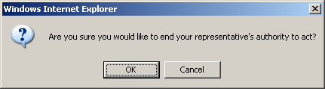
- Select OK to continue.

The Representative list screen updates.
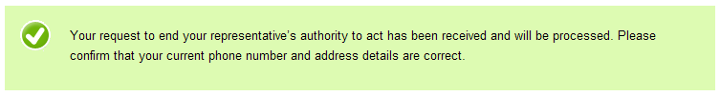
If the representative holds multiple roles, to end a specific role:
- Select the End role link against the specific representative.

The End representative role screen displays.
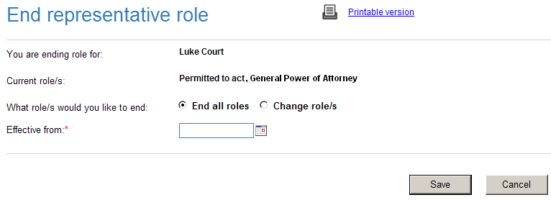
The current roles held by the representative are displayed.
- Select if you would like to either End all roles, or Change role/s.
- Depending on your selection for What role/s would you like to end, additional fields will display:
Option | Details
End all roles | - Enter or select a date that you would like the representatives authority to cease from.
   | When entering dates, you can use the calendar tool ( ) to select a date from a calendar. Alternatively, enter dates in the format dd/mm/yyyy.
  If the representative was receiving payments on your behalf, you will need to specify which bank account the payment will now go to.
Change role/s | The End representation role updates.  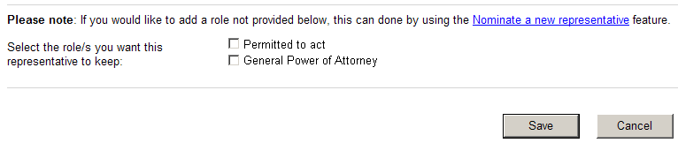  - Select which role you want the representative to keep by ticking the appropriate check box.
  If the representative was receiving payments on your behalf, you will need to specify which bank account the payment will now go to.

- Click on the Save button.

The Representative list screen updates.
Until the request is processed and approved, the representative will still appear in the Current representatives section.

Current requests to act on your behalf
The Current request to act on your behalf section displays a list of requests for representation that have been submitted in the last 12 months.
For each request you may have the following options:
- view
- accept
- refuse
- print.

The Current requests to act on your behalf section.
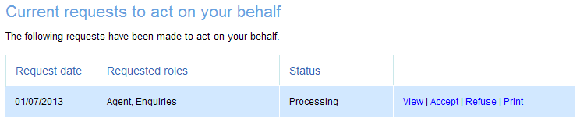
Options for
the request
This screens displays the following information about the request:
- date the request was submitted
- the representation role the request is for
- the status of the request.

View the request
To view a submitted request you need a copy of Adobe Reader (or Adobe Acrobat). This may already be installed on your computer.
If required, you can get a free copy of Adobe Reader at: http://get.adobe.com/reader/

To view a submitted request:
- Click on the View link.

The File Download dialog box displays.
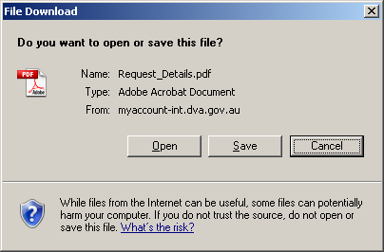
- Click on the Open button.

The request displays in Adobe Acrobat.
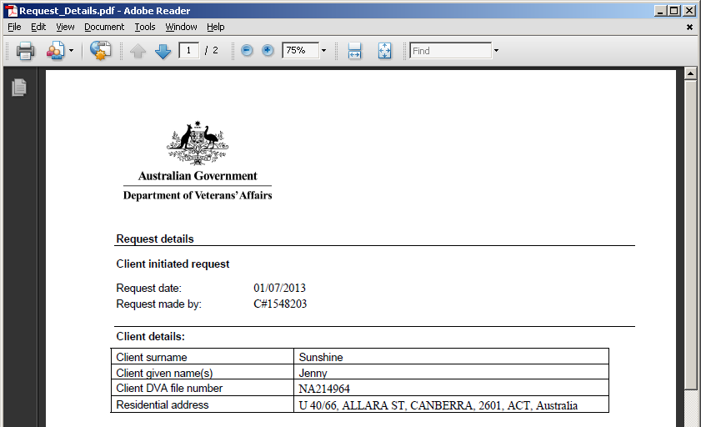

Accept the request
You can accept / approve requests when the request has been lodged by the representative.
- Click on the Accept link to approve the request for representation that was initiated by the client.
This option is only available for requests for the representation roles of Agent, Power of Attorney, Permitted to enquire or act and are initiated by the representative and the status of that request is ‘processing’.

The success message displays.
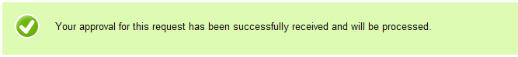

Refuse the request
You can refuse / deny requests when the request has been lodged by the representative.
This option is only available for requests for the representation roles of Agent, Power or Attorney, Permitted to enquire or act and are initiated by the representative.

- Click on the Refuse link to deny the request.

The Warning Dialog displays.
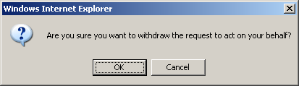
- Click OK if you are sure you want to deny the request.

The success message displays.
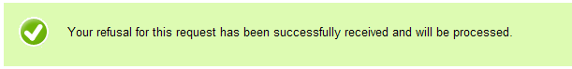

Print the request
You can print the request details and the client and representation declaration section.
This option is not available for requests that have been withdrawn or declined.

- Click on the Print link for the desired request.

The request screen displays.
- Click on the Print link located at the bottom right of the screen.
- Sign a copy of the request.

The client signature block in the declaration section will be pre-populated with your name and the date the request is submitted. The declaration checkbox will be automatically ticked.

Requests that are not submitted
The Requests that are not submitted section lists requests for representation that you have saved as a draft.
For each draft you have the following options:
- edit request
- delete request.

The Requests that not submitted requests section displays.
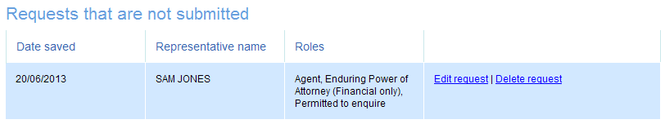
This screens displays the following information about the request:
- the date saved
- the representative’s name the request is for
- the representation role/s the request is for.

Other functions
 | To view another section and information from My details, click on a link in the My details menu to the left of the page.
 | To get additional help with the Publications screen, click on the Help button at to the top right of the page.
 | When you are finished using MyAccount, to log out and finish using the service in a secure way, click on the Logout button.

